scp

* secure copy, securely copies files between your local machine to linux server

cp source destination

scp username@host : destination local.destination

scp local.file username@host : destination

sftp

* secure file transfer protocol

sftp username@hostname

sftp [ysseo@matrix.senecacollege.ca](mailto:ysseo@matrix.senecacollege.ca)

lls ls

lpwd pwd

lmkdir mkdir

lcd cd

mail ysseo@myseneca.ca + enter

subject line + enter

body

ctrl + d to send email

1. Upload (copy the other.txt file from your local machine to your remote Matrix server)

scp other.txt [yoursenecaid@matrix.senecacollege.ca](mailto:yoursenecaid@matrix.senecacollege.ca):

2. Upload (copy the other.txt file from your local machine to ~/slgULI/week9session directory in remote Matrix server)



1. Download (copy the other.txt file in the home directory in your Matrix account to your local directory on your home computer)

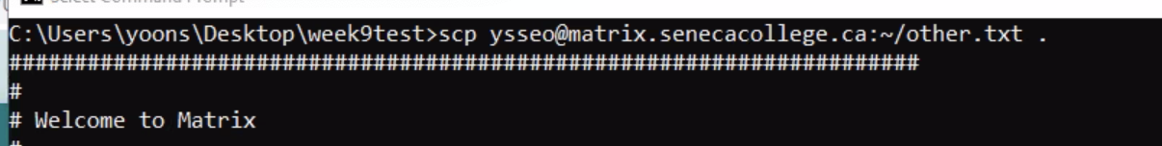

2. Download (copy the file called myfile.txt in the ~/remote directory that you created earlier in your Matrix account to your local directory on your home computer)

scp yoursenecaid@matrix.senecacollege.ca:remote/myfile.txt .

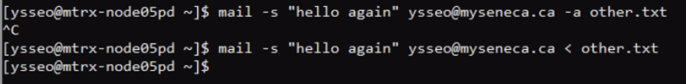

These two command doesn’t work.

First one: -a other.txt should be stated at first

Second one: there was NO customized subject line, since you redirected standard input (stdin) from the file, so there was no way for the user to send a subject line.

